Family Enterobacteriaceae
Enterobacteriaceae is the largest family of Gram-negative bacilli that has medical and veterinary importance.
It contains more than 51 genera and about 238 species.
لو حبينا نقسم هذه العائلة على حسب إحداثها للأمراض
They can be grouped into three categories;
- Pathogenic group includes Salmonella serotypes, E. coli, and Yersinia spp. In addition to Shigella in Human.
ودول هما اللى هنتكلم عنهم بالتفصيل عدا الـ Shigella
- Opportunistic pathogens includes Klebsiella, Proteus, Citrobacter, and Enterobacter.
ودول مش هنتكلم فيهم الا عن الـ Proteus
- Non-pathogenic group.
ودول مش هنتكلم عنهم طبعا لأنهم مش بيسببوا أمراض
General characters of Enterobacteriaceae:-
هنا هنتكلم عن الصفات الميكروبيولوجية العامة التى يشترك فيها هذا العدد الكبير من البكتريا ودى مهمة وهتسهل فهم الأنواع لما هنشرحها بصفة مفردة فيما بعد فنلاقى الكلام بيتكرر من الصفات دى.
- Enteric bacilli; many of Enterobacteriaceae members present in intestine of animals and human as a part of intestinal flora
ومن هنا سميت هذه العائلة بهذا الأسم Enterobacteriaceae
وبيترتب على ذلك ما يلى

- Enterobacteriaceae members can tolerate bile and so bile is used as a selective inhibitory substance in culture media used for isolation Enterobacteriaceae members as MacConkey agar where inhibits growth of all bacteria except Enterobacteriaceae members.
- Direct microscopical examination for stool/faeces samples in diagnosis of GIT diseases caused by Enterobacteriaceae members has no value
لأن كدة كدة هلاقى Gram-negative bacilli فى الشخص السليم والمريض
- Stool samples must be inoculated into enrichment media as tetrathionate broth or selenite F broth then subcultured on solid media.
الخطوة دى (enrichment) بعملها عشان اثبط نمو الـ Enterobacteriaceae membersالموجودة طبيعى كـ intestinal flora وأنمى الـ Pathogenic Enterobacteriaceae لو موجودة لانى لو معملتهاش هيحصل نمو للـ intestinal flora وبالتالى هيكون التشخيص خاطى لأن ممكن يكون سبب الـ GITD مش Enterobacteriaceaeوانا هكتب النتيجة أحد الـ Enterobacteriaceae members نتيجة لنمو الـ intestinal flora
- Stool samples must be cultivated on highly selective media along with MacConkey agar.
- Gram-negative rods, non-spore forming and most of them are motile via peritrichous flagella except Shigella, Klebsiella, S. Pullorum and S. Gallinarum which are non-motile.
Yersiniae are non-motile at 37° C but several species are motile at 25-29°C.

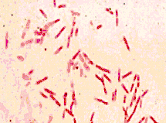

- They are aerobic or facultative anaerobes and grow optimally at 37°C.
- All of them
  - Oxidase negative,
هذا الإختبار هو أول إختبار بيوكيمايئى بعملة فى تشخيص أى مرض عزلت منه gram-negative bacilli.
لانه بيفرقلى ما بين الـ Enterobacteriaceae وما بين كل الـ gram-negative bacilli other اللى هى Oxidase positive وبالتالى التعرف سريعا على مسبب المرض.

  - Ferment glucose with acid production.
  - Reduce nitrate to nitrite.
  - Catalase positive.
- According to lactose fermentation, Enterobacteriaceae can be classified into two main groups:
a) Lactose fermenters include Escherichia, Klebsiella, Citrobacter and Enterobacter. They produce pink colonies on MacConkey agar
b) Lactose non-fermenters include Salmonella, shigella, Yersinia and proteus. They produce pale yellow colonies on MacConkey agar.
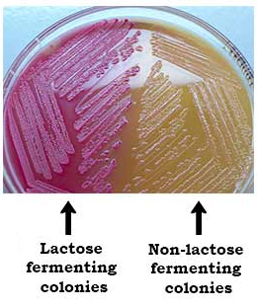
ولذلك أثناء التشخيص بقدر اتعرف على الـ Enterobacteriaceae members من خلال نموها على الـ MacConkey
Term coliforms were previously used to describe lactose fermenters.
- Enterobacteriaceae have fimbriae and complex cell wall. Its lipopolysaccharide consists of three components; somatic O polysaccharide, central core polysaccharide and lipid A.
- Antigenic structure
a) Somatic (O) antigen; consists of O-specific polysaccharide of LPS, heat stable antigen.
b) Flagellar (H) antigen; consists of flagellar proteins of motile species, heat labile antigen.
c) Capsular (K) antigen; consists of capsular polysaccharide in capsulated species, heat labile antigen. It is heavy in Klebsiella (mucoid colonies).
هذه الإنتيجينات زى ما هنشوف فيما بعد بتستخدم فى الـ typing of bacteria
Identification and differentiation of Enterobacteriaceae members:-
هذا العنوان ليس محل سؤال وانما فقط عبارة عن تجمعيه للصفات الميكروبيولوجية للتعرف على الـ
Enterobacteriaceae members وكيفية التفريق بينها أثناء التشخيص وهيفيدنا لما هنشرح الأنواع بصفة مفردة فيما بعد وجزء كبير منها مكرر مما سبق وتم دراستة بالعملى بالترم الأول
- Morphology: ; كما قيل سابقا
Gram-negative rods, non-spore forming and motile except Shigella, Klebsiella, S. pullorum and S. gallinarum which are non-motile.
Yersiniae are non-motile at 37° C but several species are motile at 25-29°C.
- Growth on MacConkey agar: كما قيل سابقا
a) Lactose fermenters (E. coli, Klebsiella, Citrobacter and Enterobacter) produce pink colonies.
b) Lactose non-fermenters (Salmonella, shigella, Yersinia and proteus) produce pale yellow colonies.
- Growth on selective media:
a) On EMB, E. coli produces dark colonies with green metallic sheen while Klebsiella produces pink mucoid colonies.
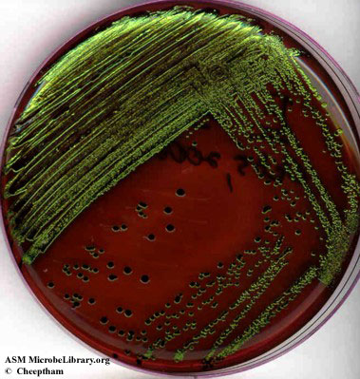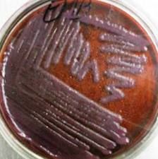
b) On Bismuth sulphate agar, Salmonella produces brown to black colonies.
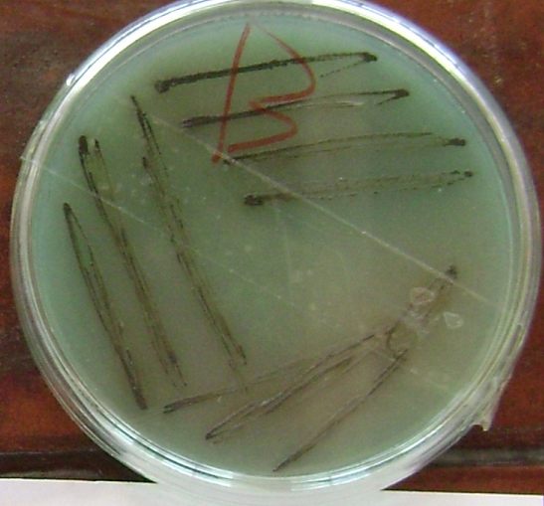
- Biochemical reactions:
كما قيل سابقا عدا الجدول الذى تم دراسته بالعملى والترم الأول
  - Oxidase negative.
  - Ferment glucose with acid production.
  - Reduce nitrate to nitrite.
  - Catalase positive.

Bacteria | IMVC test | Reaction on TSI | Urease | H₂S
E. coli | + + - - | Yellow (Acidic) butt and slant | Negative | Negative
Klebsiella | - - + + | Yellow (Acidic) butt and slant | Positive | Negative
Salmonella | - + - + | Yellow (Acidic) butt and red slant (Alkaline) | Negative | Positive in some serotypes
Proteus |  | Black (Acidic) butt and red slant (Alkaline) | Positive | Positive

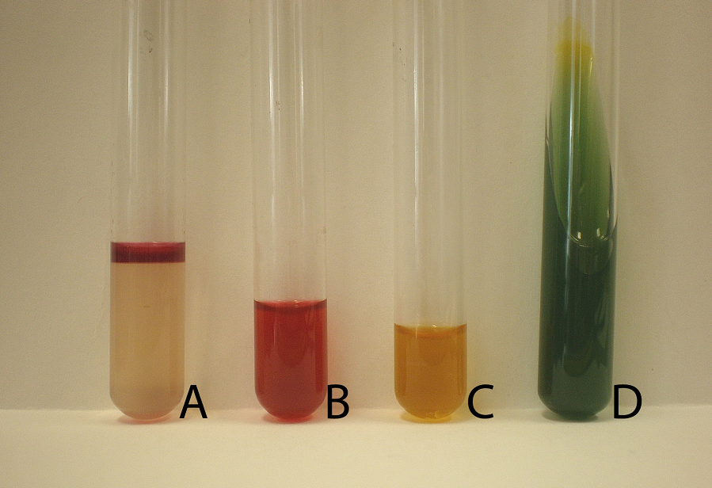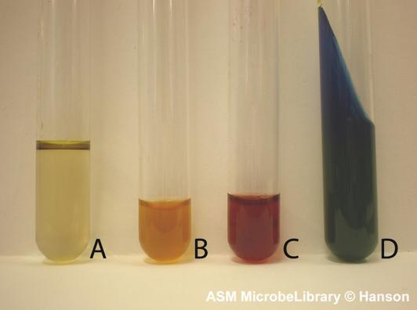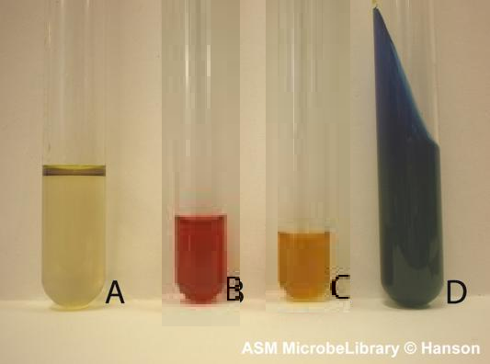
IMVC tests على الترتيب
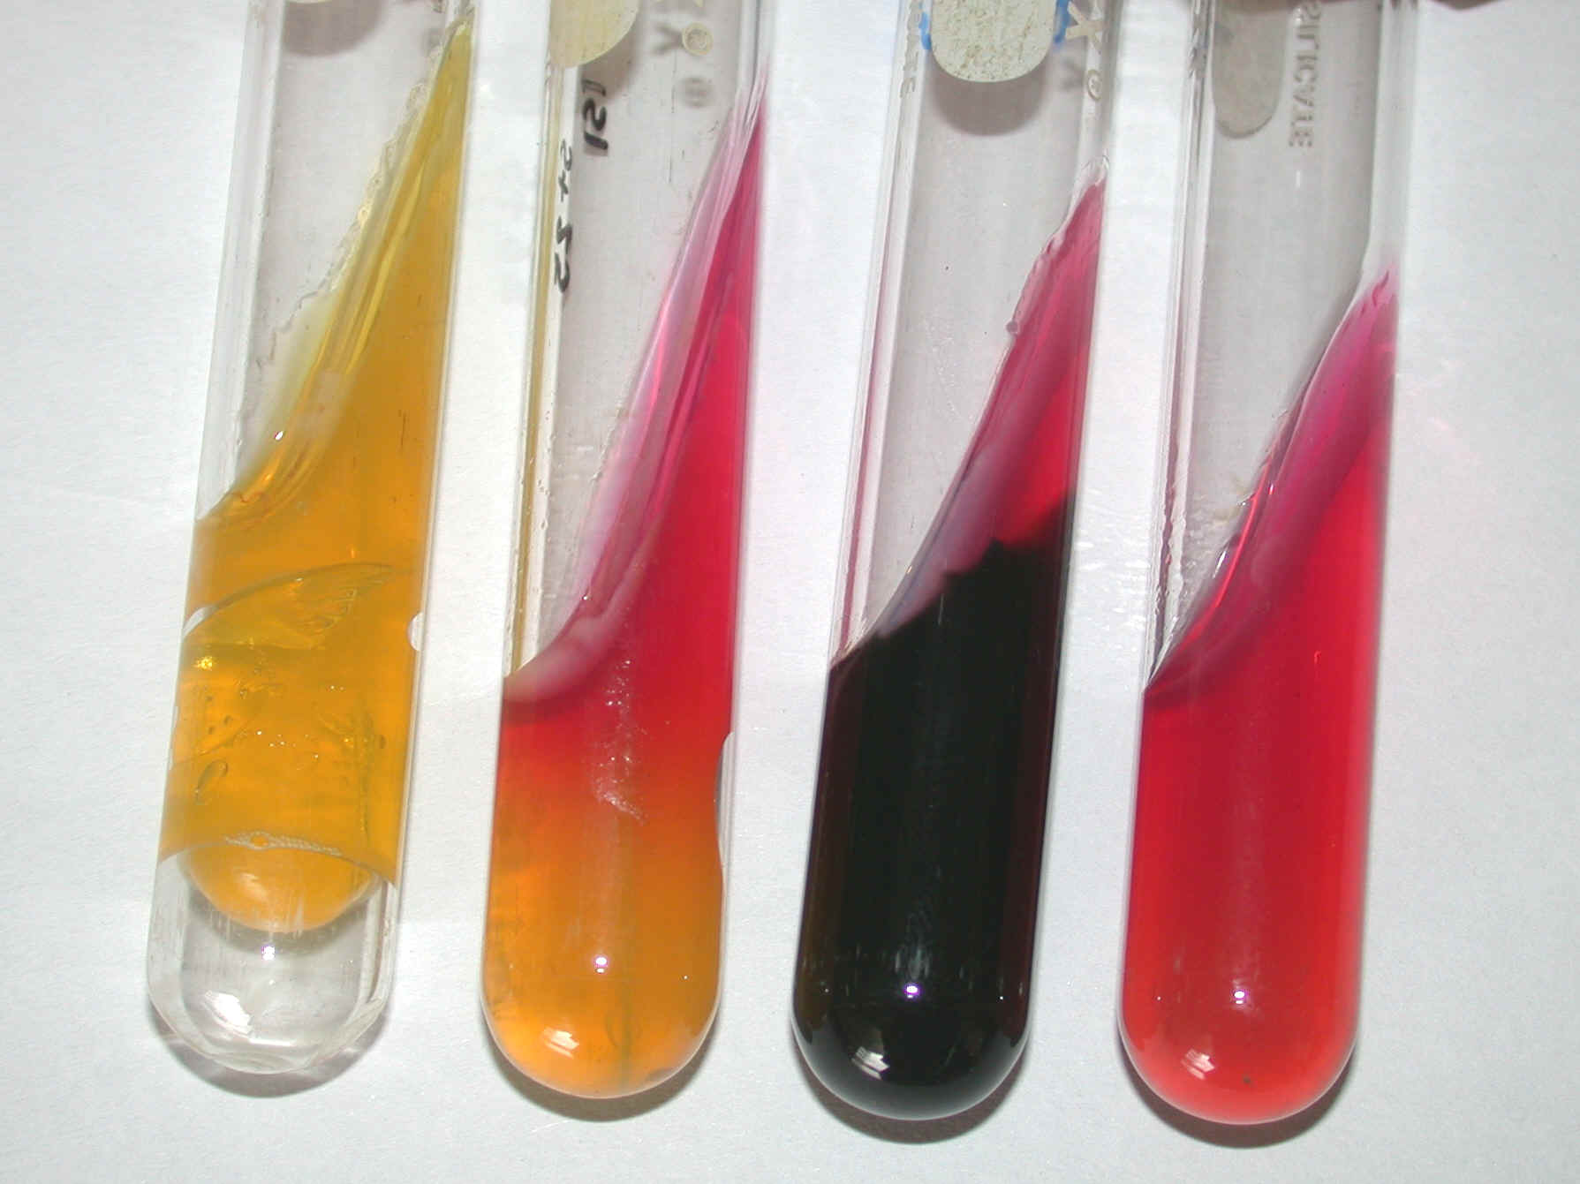
Reaction on TSI

- Others:
On ordinary media or blood agar, proteus produces characterstic swarming appearance while on MacConkeys agar media, swarming appearance is inhibited by bile salts.
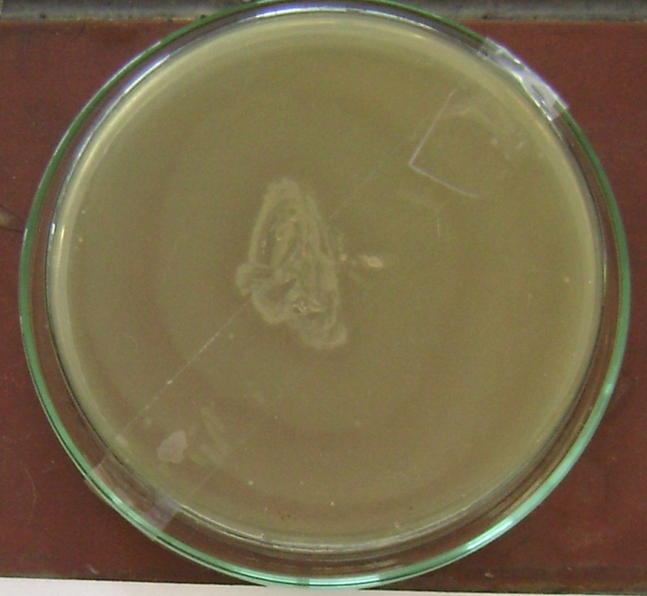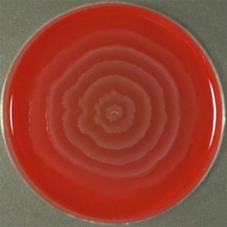

Escherichia coli
Only some strains of E. coli are pathogenic while most of them are harmless and present as a part of the normal flora in the intestine and benefit the hosts through synthesis of vitamin K and prevention establishment of the pathogenic bacteria in intestine but these strains may cause infections in extra intestinal locationsلو انتقلت الى داخل الجسم كما تم شرحه بالترم الأول .

E. coli, Enterococcus faecalis and Cl. Perfringens are used as indicators of faecal pollution of water and food contamination.
نظرا لوجود هولاء الأنواع الثلاثة من البكتريا كـ intestinal flora فأن وجودهم فى الماء أو الطعام يدل على تلوث الماء أو الطعام بالبراز وبيتم الكشف عن هذه الميكروبات فى محطات المياة للتاكد من عدم تلوث الماء بالبراز.
Morphology: قيل سابقا
• Gram negative rods, non spore-forming.
• Most strains are motile with peritrichous flagella and fimbriated.
• Some strains produce capsule and is often mucoid

Culture characteristics: قيل سابقا
• Facultative anaerobes and grow optimally at 37°C.
• On MacConkeys agar media, it produces pink colonies.
• On EMB, it produces dark colonies with green metallic sheen.

Biochemical reaction: قيل سابقا
• Oxidase negative, catalase positive and reduce nitrate to nitrite.
• Ferment glucose, lactose, maltose and sacrose with production of
acid. On TSI, it produces yellow (acidic) butt and slant.
• Urease negative.
• IMVC Test: +Ve +Ve -Ve -Ve

Serotypes of E. coli:
• E. coli is serotyped on the basis of Somatic (O), Flagellar (H) and Capsular (K) antigens and each serotype is described by numbers of these antigens Ex. O139:K82:H2.
• At the present, there are 170 O antigens, 56 H flagellar and 80 K antigens.

Diseases caused by E. coli:-
  - Urogenital tract infections. Uropathogenic E. coli is the most common cause of urinary tract infection (cystitis and pyelonephritis).
ولذلك لو أشتغلت فى معمل تحاليل هتلاقى أكتر من 90 % من المزارع البكترية لحالات الـ UTI بتعزل منها E. coli وللاسف فى معامل مش بتعمل مزارع هذه الحالات وبتضرب نتايجها وبتكتبها E. coli
  - Mastitis.
  - White scours or colibacillosis in young calves. It is characterized by grayish white diarrhea, septicaemia and death.
والمرض دا بيجى لكتير من ال calves
  - Joint ill or navel ill in foals. It is caused by E. coli, Strep. equi and Shigella equirulis.
  - CCRD (complicated chronic respiratory disease) in chicken. Chronic respiratory disease is caused by Mycoplasma gallisepticum.
هيتم شرح هذا المرض فيما بعد فى الميكوبلازما
  - Coli-granuloma or Hijarre’s disease in poultry. It is characterized by formation of granuloma in wall of GIT and liver.
  - Different stains of Enteric E. coli causes diarrhea by different mechanisms
    - Enteropathogenic E. coli (EPEC); affects human, rabbits, dogs, cats and horses. They adhere tightly to the intestinal epithelium by intimin pili destructing the microvilli and cupping the cells and subsequently preventing their normal functions of absorption and secretion resulting in diarrhea.
    - Enterotoxigenic E. coli (ETEC); affects human and animals. They adhere to the intestinal epithelium by pili and produce two enterotoxins (LT and ST) stimulate fluid and electrolytes secretion into the intestine and prevents their absorption resulting in watery diarrhea.
    - Enteroinvasive E. coli (EIEC); affects human. They penetrate, invade and destruct the intestinal epithelium resulting in profuse dysentery and high fever (identical to Shigellosis).
    - Enterohaemorrhagic E. coli (EHEC); the most famous strain is O157:H7. They affect human, cattle and goats. They produce verotoxin/ shiga toxin cause necrosis for the enterocytes and vascular cells resulting in bloody diarrhea (no fever), in some patients may end up with the life threatening haemolytic uraemic syndrome (haemolytic anaemia, thrombocytopenia and acute renal failure).
    - Entreroaggregative E. coli (EAggEC); affect human. They adhere to mucosa in patches and produce a ST-like toxin and a haemolysin resulting in persistent watery diarrhea (no fever).
  - In human, E. coli is one of the most common causes of septicemia and meningitis among neonates. It is acquired in the birth canal before or during delivery.
  - In human, E. coli causes pneumonia, septicemia and endotoxic shock following any E. coli infection especially in the immunocompromised hosts or neonates.
  - E coli is one of the major nosocomial pathogens.
الميكروبات التى تسبب إصابات فى المستشفيات للمرضى تشمل and Staph. Aureus, E coli , Pseudomonas aeruginosa
Virulence factors of E. coli:
عوامل الضراوة دى ممكن نستخلصها مما سبق
  - Pili; mediates adherence of bacteria to the mucosal surfaces.
  - Capsular polysaccharide (in capsulated strains); antiphagocytic and resists the complement.
  - Lipopolysaccharides (LPS); Endotoxin (lipid A) responsible for signs of the endotoxic shock associated with E.coli infections which may lead to death.
  - Heat stable (ST) and heat labile (LT) enterotoxins produced by Enterotoxigenic E. coli (ETEC); they stimulate fluid & electrolytes secretion into the intestine and prevent their absorption resulting in watery diarrhea.
  - Verotoxin or shiga toxin produced by Enterohaemorrhagic E.coli; they cause necrosis for the enterocytes and vascular cells (haemorrhagic colitis and haemolytic uraemic syndrome).
  - Haemolysins produced by some strains of E. coli.

Laboratory diagnosis of diseases caused by E. coli:
هنا زى ما قلنا فى البروسيلا المكتوب عنواين فقط لكن فى حالة السؤال عن تشخيص مرض ما فى الإمتحان بنكتب شرح كل عنوان من الشرح السابق
- Sampling: According to the infection.
Enrichment step in case of stool sample
2) Microscopical examination
Not performed in case of diagnosis of GIT diseases where has no value.
3) Isolation and identification.
4) Serotyping using slide agglutination test.
5) ELISA for detection of toxins.
6) PCR for detection of toxin genes.

